Virtual LAN (VLAN)

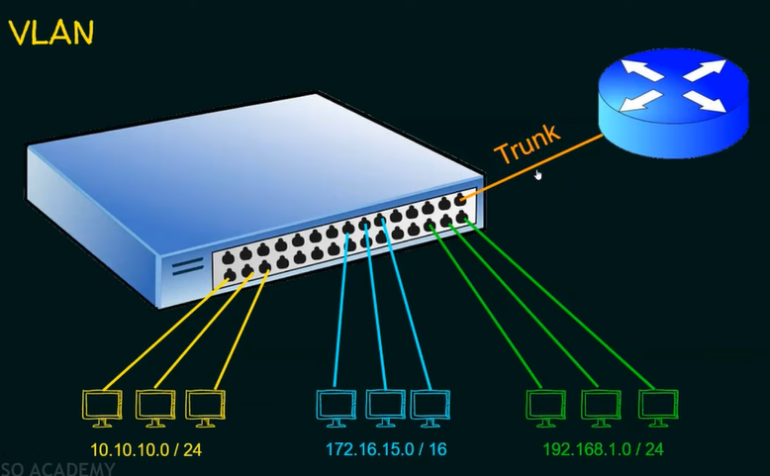

1. A VLAN is a logical partition of a Layer 2 network
2. Mukltiple paritions can be created, allowing for multiple VLANs to co-exist.
3. Each VLAN are mutually isolated and packets can only pass between them via a router.
4. The partitioning of Layer 2 network takes place inside a Layer 2 device, usually via a switch.
5. The hosts grouped within a VLAN are unaware of the VLAN’s existence.

Benefits of VLAN

1. Security
2. Cost reduction
3. Better performance
4. Shrink broadcast domains
5. Improved IT staff efficiency
6. Simpler project and application management

Types of VLAN

1. Data VLAN
2. Defualt VLAN
3. Native VLAN
4. Managmeent VLAN
5. Voice VLAN

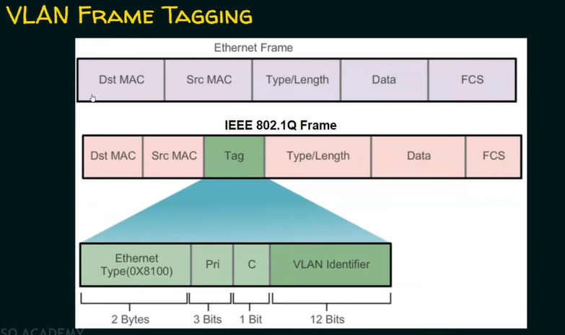

1. Frame tagging is the process of adding a VLAN identification header to the frame.
2. It is used to properly transmit multiple VLAN frames through a trunk link.
3. Switches tag frames to identify the VLAN to they belong. Different tagging protocol exist; IEEE 802.1Q is a very popular example.
4. The protocol defines the structure of the tagging header added to the frame
5. Switches add VLAN tags to the frames before placing them into trunk links and remove the tags before forwarding frames through non-trunk ports.
6. When properly tagged, the frames can transverse any number of switches via trunk links and still be forwarded within the correct VLAN at the destination.